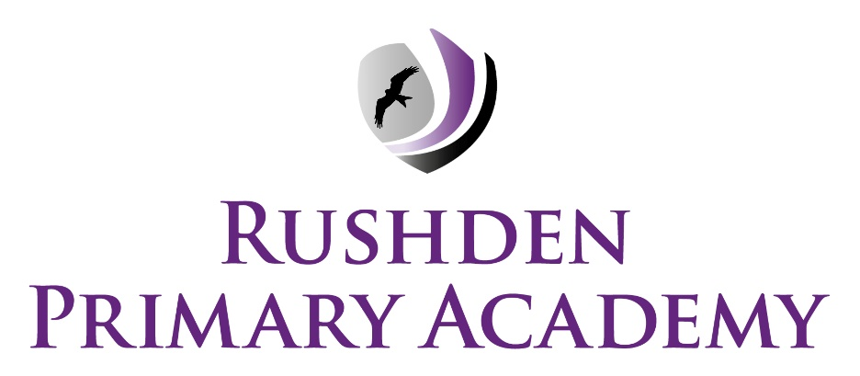
Behaviour & Exclusion Protocol
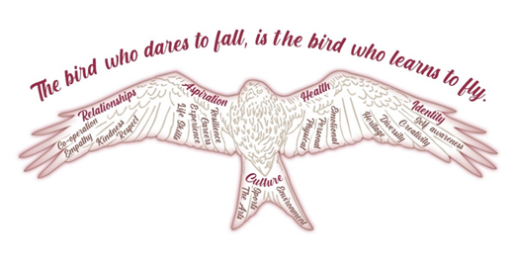

Respect yourself and others

Take pride in your environment

Achieve your goals
Review process:
First written Sept ‘22
Reviewed April ‘26
Review Due April ‘27
“You can be strict without being nasty, maintain boundaries without cruelty and correct children without aggression”. (Paul Dix, Pivotal Education)

Statement of Principles

Rushden Primary Academy is committed to creating an environment where exemplary behaviour is actively recognised through positive noticing and sits at the heart of productive learning. Everyone is expected to maintain the highest standards of personal conduct, to accept responsibility for their behaviour and encourage others to do the same. Our behaviour protocol guides staff to teach self-discipline not blind compliance and echoes our core values with a heavy emphasis on respectful behaviour. Children, who are able to master the essential skills, can make the most of their time in school and thrive in their wider lives. Therefore, all children are introduced to our school rules in EYFS. The academy works with the Skills Builder Partnership to support every child to build those skills as a core part of their learning and rules and values are reshared with pupils on the first morning of each term in our ‘Equality, Diversity and Inclusion’ mornings.

The school has 3 golden rules ‘Respect, Pride and Achieve’, which can be applied to a variety of situations and are taught and modelled explicitly.

Equality

Reasonable adjustments are made, where the behaviour is due to a reason related to a child’s special educational needs or disability, thereby ensuring that children with SEND are not placed at a disadvantage or unlawfully discriminated against. RPA will work closely with all parents/carers of children with behaviour challenges and formulate adaptations if necessary.

Staff seek to identify the underlying cause of any unacceptable behaviour, for example an unmet special educational need, which needs investigating by one of our trained professionals, or to identify any ‘triggers and patterns’ to try and prevent the challenging behaviour persisting or worsening.

Pupils with specific needs

Individuals who have an EHCP, identified special needs in terms of behaviour, or a protected characteristic, may need the whole Academy Behaviour Management System to be modified to positively manage their behaviour. For these pupils there will be a Behaviour Support Plan written by the SENDCo in consultation with teachers, support staff and parents/carers and reviewed regularly. Individual behaviour plans are shared with all members of staff.

Aims of the Protocol
- To create a culture of exceptionally good behaviour: for learning, for community, for life.
- To ensure that all learners are treated fairly, shown respect and to promote good relationships.
- To refuse to give learners attention and importance for poor conduct.
- To help learners take pride in, and control over their behaviour and be responsible for the consequences of it.
- To help learners acknowledge that they can achieve their goals.
- To build a community which values kindness, care, good humour, good temper, and empathy for others.
- To promote community cohesion through improved relationships.
- To ensure that excellent behaviour is a minimum expectation for all.
- To guide individuals in mastering the eight essential skills in order to capture success.
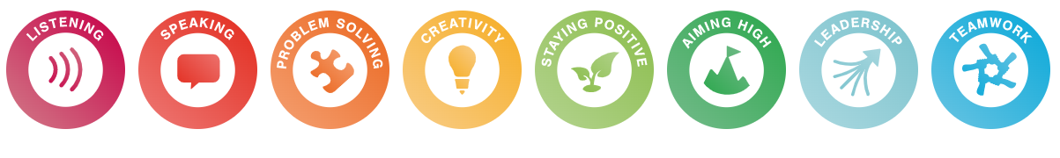

Expectations of Adults
Consistent adult behaviour will lead to pupils consistently conforming to our expectations. Behaviour training is woven into every staff meeting to keep a shared focus on consistent, positive practice.

We expect every adult to:
- Meet and greet our families every morning. Teacher at the classroom door, SLT on the playground gates and support staff within the classroom.
- Refer to ‘Respect, Pride, Achieve’.
- Model positive behaviours and build relationships.
- Plan lessons that engage, challenge and meet the needs of all learners.
- Use positive noticing consistently throughout the day.
- Offer dojos as rewards at every opportunity in and around the school.
- Be calm and give ‘take-up time’ when going through the steps. Prevent before sanctions.
- Follow-up every time, retain ownership and engage in reflective dialogue with learners.
- Never ignore or walk past learners who are making poor choices.
- Set high expectations of our pupils to be responsive throughout the school day (eg, SLANT, wonderful walking, wonderful waiting).

Recognition and rewards for effort: ‘over and above’
We recognise and reward learners for following our golden rules. Our staff understand that at Rushden Primary Academy we recognise that the use of praise in developing a positive atmosphere in the classroom cannot be underestimated and a quiet word of personal praise can be as effective as a larger, more public reward. It is the key to developing positive relationships, including with those learners who are hardest to reach.

Positive recognition is an important part of our approach and is used to celebrate behaviour. This includes positive messages home via Dojo, notes, phone calls, or face-to-face conversations. Pupils may also receive extra playtime, Class VIP status, house points, Flying High awards (with an accompanying afternoon high tea), and achievement awards for English, Maths, and homework.

Whole School Approach to Positive Behaviour
At Rushden Primary Academy we strive to build and maintain strong, positive relationships as the key to behaviour management. We use our three golden rules, Respect, Pride & Achieve as a consistent language to reinforce high expectations.

Consistency in Practice

- Consistent language: ‘Thank you for using wonderful walking to move around the school respectfully.’ ‘You have taken pride in our environment by picking up that litter – thank you.’ ‘You worked with the team to achieve a goal – well done!’
- Consistent follow-up: teachers take responsibility for behaviour interventions, seeking support but never delegating.
- Consistent positive reinforcement: Routine procedures for reinforcing (eg, SLANT – sit, listen, ask questions, never interrupt, track the adult), encouraging and celebrating appropriate behaviour.
- Consistent consequences: Defined, agreed and applied at the classroom level as well as established structures for more serious behaviours.

Managing and Modifying Behaviour
Learners are held responsible for their behaviour. Staff will use the steps in behaviour for dealing with poor conduct. It is the aim that learners should be kept at steps 1 and 2 for as long as possible. It is important that opportunities for reparation are offered at regular intervals.

The Academy regularly reviews our behaviour protocols, guidelines, and sanctions to ensure they are effective, consistently applied, and fair. This includes reviewing behaviour data, pupil voice, and patterns across different groups to identify any inconsistency or potential discrimination, particularly for those with protected characteristics. Findings inform staff training and adjustments to practice where needed.
1) Gentle Redirection | A non-verbal cue, e.g. a hand on the shoulder, a look, to redirect attention.  A reminder of our three simple rules – Respect, Pride, Achieve.  Positive noticing of those children who are ‘making the right choices’, shining a light on acceptable behaviours.
2) Formal Reminder | A clear verbal reminder delivered privately wherever possible in the classroom, making the learner aware of their behaviour and clearly outlining the consequences if they continue.  The purpose of this step is so the learner has a choice to do the right thing.  Learners will be reminded of their previous good conduct to prove that they can make good choices. “stop, think, ……..make the right choice”.  This will be recorded on RPA’s low level behaviour record keeper.
3) Step Out | Speak to the pupil outside of the classroom and give them a final opportunity to engage. The purpose of stepping out is to return the child back to learning as quickly as possible.  Use the 30 second scripted intervention  • I have noticed that you are...(having trouble getting started, wandering around etc.) right now. Are you ok? I thought it would be better to chat away from everything. I was wondering what was up?  • This is just a pause; I want to get you back in and working. I asked to speak to you as I noticed you were struggling to keep to our rules. At RPA, we… (refer to the 3 school rules – respect, pride, achieve)  • What do you need most, right now, to help you get back to learning? Or how can I help you? (refer to action to support behaviour e.g. moving to another table, complete learning at another time)  • Do you remember yesterday/last week when you... (refer to previous positive behaviour)?  • That is who I need to see today...  • Ok, breathe, you need to go back in. When we go back in, I am going to make it easy for you to get back to your learning. Thank you for listening... then give the child some ‘cool off’ time.
4) Reflection and Restore | If the warning is not heeded and the behaviour continues, the child will receive a sanction and this should be recorded on CPOMS, categorised as ‘Behaviour’.  The sanction is a short time after the lesson, ideally with the class teacher, to reflect on the situation. A restorative conversation will occur during this time to allow the child to reflect on their choices and refocus them to the positive outlook for the rest of their day.  5 questions are usually enough from the following:  • What happened?  • What were you thinking at the time?  • What have you thought since?  • How did this make people feel?  • Who has been affected?  • How have they been affected?  • What should we do to put things right?  • How can we do things differently in the future?  If a child has multiple incidents in a week, that have been recorded on CPOMS, the class teacher will inform parents.
If appropriate  5) Triage | Another member of staff may be asked to de-escalate a situation by resetting undesirable behaviours and a change of face. The conversation will include 5 questions from step 4, however, with a familiar face for the child to identify even more so that their choices are not acceptable and to prove that expectations are consistent in every area of the school. Therefore, giving the child another opportunity to reflect and perfect.  The Senior Leadership Team will monitor and analyse behaviour information weekly to identify any pupils, whose behaviour is persistently not improving following low-level sanctions, or whose behaviour reflects a sudden change from previous patterns of behaviour. A meeting with SLT, Family Support Worker and parents/carers will be arranged. This meeting will be documented on CPOMS, so outcomes, plans and goals are recorded.  Triage may be used earlier in the cycle, if deemed necessary.
6) Fixed Term Exclusion (suspension) | A serious breach may lead to a fixed term exclusion. Depending on the age of the children these incidents will be dealt with at the discretion of the school staff.  Serious behaviour matters will be referred to the SLT or Principal.  Such incidents could include:  • Fighting  • All forms of bullying (See anti-bullying policy)  • Racist, sexist or homophobic comments  • Using abusive/offensive language  - Verbally abusing adults.  • Physically striking adults.

Examples of Sanctions

Behaviour | Example Sanction
Name-calling or unkind comments | Restorative conversation; written or verbal apology; some loss of break (not all)
Disruption in class (e.g. calling out, distracting others) | Move seat; short time out; complete missed learning during a portion of break
Refusal to follow instructions | Time out in another class; reflective discussion; parent contact if persistent
Rough or unsafe play | Miss part of play; walk with an adult; cool-off period
Low-level dishonesty (e.g. denying a known action) | Reflective conversation or writing task; revisit expectations
Persistent low-level disruption | Behaviour chart; check-in/check-out with adult; parent meeting
Inappropriate behaviour during play (e.g. bad language, aggressive tackles, not following rules) | Temporary or permanent removal from game; restorative discussion before rejoining
Inappropriate use of school equipment | Loss of privilege; repair or clean-up duty; parental contact
Misuse of ICT in school | Temporary loss of ICT access; digital safety session; apology where appropriate
Fighting or physical aggression |  | Internal exclusion; reflection time; parent meeting (dependent on child’s individual pathway)
Repeated or serious refusal to follow adult direction |  | Behaviour support plan; SLT-led intervention; internal exclusion
Offensive language directed at others (including adults) |  | Internal exclusion; restorative conversation; parent meeting
Damage to school property (deliberate) |  | Parent informed; contribution to repair if appropriate; internal reflection time
Continued breaches of club behaviour expectations |  | Withdrawal from participation in clubs, competitions or extra-curricular activities

Playtime and Lunchtime Behaviour Expectations
We recognise that children’s behaviours on the playground may differ to those in the classroom; however, it is expected that all children follow our school rules and display the school values in all settings.

Breakfast and After School Club Expectations
Staff working in the childcare provision are fully trained and follow the school behaviour ethos. As senior leaders are not usually on site before or after school, behaviour responses differ from those used during the school day.

Expectations remain the same:
Respect yourself and others
Take pride in your environment
Achieve your goals

Most behaviour issues are resolved through discussion with staff. In rare cases where behaviour presents a safety risk or is serious, parents/carers will be contacted and asked to collect their child. Repeated incidents, or refusal to collect when requested, may result in the place being withdrawn.

Staffing ratios meet legal requirements, and additional supervision cannot be provided. Parents/carers are expected to support the provision’s behaviour expectations. A separate copy of these expectations will be given to all new and existing parents of the Breakfast and After School club provision.

Positive Handling
The Academy follows the guidelines laid down by the DfE in their advice issued in July 2013.

Positive Handling may be used:

- To prevent a pupil from causing injury to themselves or others
- To prevent a pupil from causing injury or damage to property
- Where the pupil is prejudicing the maintenance of good order and discipline at the Academy

The use of reasonable force is a last resort, and alternative strategies will be adopted wherever possible, for example contacting the parent or the police for support.

Reasonable force will never be used as a sanction and the degree of force used will be the minimum needed to achieve the necessary result.

The Academy will communicate with parents where serious incidents involving the use of force been used. It will be up to the Principal’s discretion to decide on the need to report, depending on the severity of the incident.

Behaviour Outside of the Academy Environment
The Academy expects high standards of behaviour at all times, including off-site.
Children will not be excluded from trips or residentials solely due to behaviour. During school-led activities (e.g. trips, sports events, residentials), pupils are expected to follow the full Behaviour Protocol and represent the Academy appropriately. The same expectations and sanctions apply, and parents/carers will be informed of any incidents. In some circumstances, where a child’s behaviour presents a potential risk, a risk assessment will be carried out. While every effort will be made to support participation, this may not always be possible due to resource limitations. Therefore, the school may request that a parent or carer accompanies the child to ensure their safety. A risk assessment will be completed if the child exhibits: running from staff, persistent disruption, refusal to follow instructions, physical aggression, or disrespect towards staff.

When pupils are travelling to and from school or in the local community, the Academy may apply sanctions if behaviour raises safeguarding concerns, impacts others, brings the Academy into disrepute, or undermines its standards. Decisions will consider the seriousness of the incident, whether the pupil was identifiable as a member of the Academy, and the impact on the school community.
Parents/carers will be informed and are expected to address behaviour outside school hours. While the Academy may intervene where appropriate, responsibility for community behaviour sits primarily with families.
Behaviour online
Online safety is a key part of the curriculum at Rushden Primary Academy. We use the National Crime Agency’s CEOP Education programme, ThinkUKnow, to help children understand how to stay safe online. However, most online activity takes place outside of school, and national guidance makes it clear that parents and carers play the principle role in monitoring and managing their child’s digital use.
Guidance from the UK Council for Internet Safety highlights the importance of parental controls, regular monitoring, and open conversations. The Academy does not have the capacity or resources to investigate or resolve online incidents that occur at home.
We strongly encourage families to consider whether children need smartphones. Where the purpose is contact while travelling to and from school, a basic non-internet phone offers the same safety without added online risks. Many popular apps, including WhatsApp, Snapchat, TikTok, Instagram, and Discord, have age restrictions (13+) due to the nature of their content.
While the Academy will support where appropriate, incidents involving online platforms and personal devices are home matters. Parents and carers are expected to check phones daily and ensure children do not have unsupervised access, including in bedrooms.
Mobile Phones
For safety reasons, children who walk to and from school independently may bring a mobile phone to school. To support safeguarding, protect pupils’ privacy, and ensure learning is not disrupted, phones must be switched off and stored securely in the classroom cupboard at the start of the day. Phones will be returned to children at the end of the school day and should only be used before and after school, once pupils have left the school premises. The Academy accepts no responsibility for lost or damaged phones. They are brought to school at the owner’s risk.
Pride in our Uniform
We take pride in our identity and the way that we present ourselves. The Academy uniform, as detailed in our Academy’s uniform policy, should be worn by all pupils.
Where a pupil attends the Academy without the correct uniform (and no prior communication has been made by parents), the following process will be followed:
- a Dojo will be sent to parents
- a formal communication will be made by the office requesting that the child be in correct uniform the following day
- a call home will be made so that the correct uniform can be brought to the Academy that day
- a meeting arranged with parents
Suspensions and Exclusions
Please click this link to access the GAT Suspensions and Exclusions Policy.

