PSHE – Rushden Primary Academy
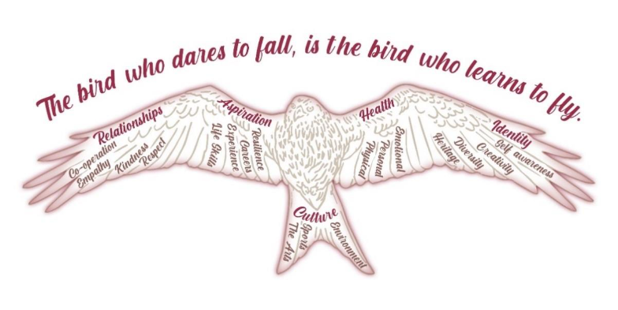

Our PSHE coordinator is Miss Devonald.

Statement of intent:
At Rushden Primary Academy, our intent is to build a PSHE curriculum, which develops learning, and results in the acquisition of knowledge and skills, enabling children to access the wider curriculum, work collaboratively with others and make a positive contribution to the life of the school. Our curriculum will prepare children to be a global citizen in a diverse society rich with culture and prepare them for the opportunities, responsibilities and experiences they will face in life. PSHE is taught across the whole school from EYFS – Year 6 on a weekly basis and as a school, we follow the Jigsaw PSHE scheme. Our PSHE sessions will equip children with relevant and meaningful content, which is supported through a strong emphasis on emotional literacy, building resilience and nurturing mental and physical health.
Implementation:
Our whole curriculum is shaped by our school vision which aims to enable all children, regardless of background, ability and additional needs, to flourish and develop a strong sense of identity to become the very best version of themselves they can possibly be. We teach the National Curriculum, supported by a clear skills and knowledge progression. This ensures that skills and knowledge are built on year by year and sequenced appropriately to maximise learning for all children.
Jigsaw PSHE directs our aim on developing the “whole child” through a spiral curriculum approach to developing knowledge, skills and understanding in the areas of;
· Being Me in My World
· Celebrating Difference
· Dreams and Goals
· Healthy Me
· Relationships
· Changing Me
It also identifies links to British Values, and SMSC and is taught in such a way as to reflect the overall aims, values, and ethos of the school.
Wider Curriculum
- We believe that focusing on developing a 'Growth Mindset' in our children will help them to build resilience, independence and confidence; embrace challenge; foster a love of learning; and increase their level of happiness. We do this through the language we use in class, praising children for their efforts, and using language to encourage children to change their way of thinking.
- PSHE, including SMSC and BV, is an integral part of the whole school curriculum, and is therefore often taught and planned within other subject areas.
- Visitors such as emergency services and the school nurse complement our PSHE curriculum to offer additional learning as well as external trips outside of school.
- We promote special days and events in school that focus on wellbeing. This includes Mental Health Days and Anti Bullying Week.
- Monday assemblies are linked to PSHE, British Values, SMSC and our school values to cover any additional sessions that would benefit the whole school.
- PSHE, BV and SMSC displays throughout school reinforce the PSHE curriculum enabling children to make links.

Impact:
What will this look like? By the time children leave Rushden Primary Academy they will:
All have a ready willingness and ability to try new things, push themselves, face challenges and persevere with strong aspirations and goals. To have a good understanding of how to stay safe, healthy and develop good relationships. To have an appreciation of what it means to be a positive member of a diverse, multicultural society. To have a strong self-awareness, interlinked with compassion of others and most importantly to be happy within themselves.

