

Special Educational Needs and Disabilities (SEND)
Information Report

Review of the Academic year 2024-2025

  Our Academy | Our Academy Vision  At Rushden Primary Academy the well-being and development of each child underpins all that we do. Our aim is to develop children into confident and resilient learners, for them to develop a love of learning and to encourage them to explore opportunities to step outside of their comfort zone whilst not neglecting the need to develop wider life skills that they can use to underpin their future development.  Changing demographics of SEND Support at RPA  At the end of the 2023-2024 academic year, RPA had 48 children on the SEND register, including 5 with an Educational Health Care Plan (EHCP). With 392 children on roll, our SEND register accounted for 12.2% of the school population. This was 4.9% below the national average.  At the end of the 2024-2025 academic year our overall register had shrunk slightly bringing the total number of children on the register to 46 however, the level of need had significantly grown as we now have 13 children with an EHCP with another four well through the assessment progress. Additionally, a further two families with children having been awarded an EHCP have chosen to join RPA in September 2025, bringing our EHCP total to 19. The highest in Rushen Primary Academy’s history.  Here at RPA we are firmly committed to supporting children with SEND, recognising the profound impact that inclusive, tailored education can have on a child’s development and future. We work tirelessly to create an environment where all pupils feels valued, understood, and empowered to thrive academically, socially, and emotionally.  However, this is not without its challenges. The complexity and diversity of needs, coupled with increasing demand for specialist support, place significant pressure on school resources. Navigating external referrals, securing timely interventions, and meeting statutory requirements often requires us to go above and beyond, despite very limited external funding, which puts pressure on our staff and existing budgets.  Despite these obstacles, we continue to innovate, collaborate, and advocate for every child. Our commitment to inclusion is unwavering, and our determination to break down the barriers our children face is a testament to the RPA team who work tirelessly for the children in our care. Supporting children with SEND is not just a responsibility; it’s a privilege.
  Meet our SENDCO Team | The SENCO team is lead by Emma Larbey who works alongside Charlotte Tamkin and Rachel Wright. Rachel is first point of contact for children and families who have an EHCP while Charlotte supports the children who don’t need or haven’t yet got an EHCP.  If you would like speak to a member of the team, please call the main Academy number on 01933 201200. Alternatively you can email us at the following addresses:  Emma Larbey – elarbey@rushdenprimaryacademy.org  Rachel Wright – rwright@rushdenprimaryacademy.org  Charlotte Tamkin – ctamkin@rushdenprimaryacademy.org
  Special Educational Needs | At Rushden Primary Academy we support children with all types of special educational needs, and pride ourselves on being a highly inclusive Academy with an ethos which encourages and celebrates diversity and inclusion.  Special Educational Needs are categorised into the following areas in the SEN code of practise 2014:
   | Cognition and Learning
   | Communication and Interaction
   | Social, Emotional and Mental Health
   | Sensory and Physical
  Identifying and Assessing Need | All the staff work closely as a team and if a concern is raised about a child, we begin by discussing concerns with parents. Teachers will, with support from parents create a Learning Plan with a six-week assessment period and the Graduated Response approach of ‘Assess, Plan, Do and Review’ will be followed. The Learning Plan is shared with families.  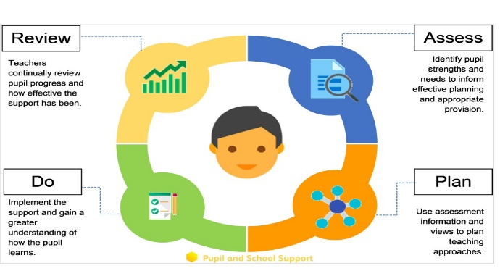  After the initial six-week period and further consultation with parents, it is decided the a child needs to be placed on the SEND register. The SEND register can be very fluid, and just because a child is added to it, doesn’t mean that they stay on it for the entirety of their school career. The SEND register highlights and ensures that all staff know who needs additional help and what help they need. If a child makes accelerated progress with the support, they can and will be taken off the register if everyone is in agreement.  Some children may require more support than school can provide and we may ask outside agencies to support us in ensuring that we are offering the best support we can.  We work with the outreach team from Maplefields who specialise in supporting children with social, emotional and mental needs. https://www.maplefieldsacademy.co.uk/semh-outreach-service/  If a child has a learning need and we have exhausted all reasonable adjustments in school, we can ask for support from the Rowan Gate Team. https://www.rowangateprimary.co.uk/outreach/outreach-service  We also work closely with Northamptonshire Educational Psychology Service and our link psychologist supports a smaller number of children in the school.  All school staff have access to the SEND advice documents and these are saved on Insight. Any reports from external agencies are saved in the ‘notes’ section of Insight for all relevant staff to see and carry out the advice.
  Our approach to teaching children with SEND | We are an inclusive Academy. Wherever possible children are taught alongside their peers in flexible and adaptive teaching groups.  Teachers make reasonable adjustments to their quality first teaching to meet their pupils’ needs and plan individual timetables where necessary. When appropriate, staff are deployed to give children additional interventions in small groups outside the classroom, or to provide one-to-one support.  This year, we launched our non-designated small group provision to support children working outside of their year group expectations. The Unit, led by Rachel Wright and her dedicated team, has been a valuable addition to our inclusive offer. While the journey has involved a steep learning curve, it has also brought many successes—both academically and socially—for the children involved.  One of the unexpected challenges we encountered was just how much the children enjoyed being in the new environment. Managing transitions back to their home classrooms after their allotted sessions proved more difficult than anticipated, simply because they felt so comfortable and secure in the space—a rather lovely challenge to navigate!.  Looking ahead to the 2025–2026 academic year, we remain committed to providing high levels of adult support for those accessing The Nest and Branch provision. However, we will be placing greater emphasis on keeping children more closely aligned with their home classrooms. To support this, we’ve introduced mini hubs in shared areas across the school, designed to ease transitions and maintain continuity in learning.  We’re excited to build on what we’ve learned and continue refining our approach to meet the needs of every child, ensuring they feel supported, included, and ready to thrive.
  Curriculum adaptations | A range of strategies, such as the examples above, are employed across our lessons to ensure we offer an inclusive approach to learning and all children access the classroom environment.
   | 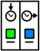 | 
  Visual timetables | Task boards | Peer mentoring
   |  | 
  Assistive technology | Talk partners | Peer marking
   |  | 
  Self-assessment | Word banks | Positive behaviour
   |  | 
  Ear defenders | Timers | Explicit instruction
   |  | 
  Unit Provision | Sensory Space | Outside Space
  Parent Consultations | At Rushden Primary Academy we work with parents and carers and recognise that they have much to contribute to our support for children with SEND.  The SENCo Team are always available to meet with parents. The team are available at parents’ evenings to discuss any concerns.  For children with an Education, Health and Care Plan, a SEN Support Provision Plan, or those requiring specialist support beyond what is ordinarily available, we will invite you to attend additional meetings throughout the academic year.  These meetings provide an opportunity to celebrate your child’s achievements, review progress against existing targets, and collaboratively set new goals. They also allow us to discuss next steps and ensure that support remains tailored to your child’s evolving needs.  Following each meeting, a written summary will be sent home for your records and reference.  During the year a parental questionnaire is sent out to gain views on the Academy and the SEND provision. The results of the most recent survey are as follows: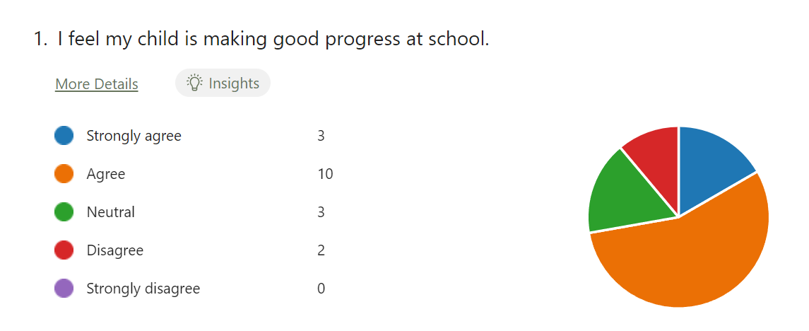  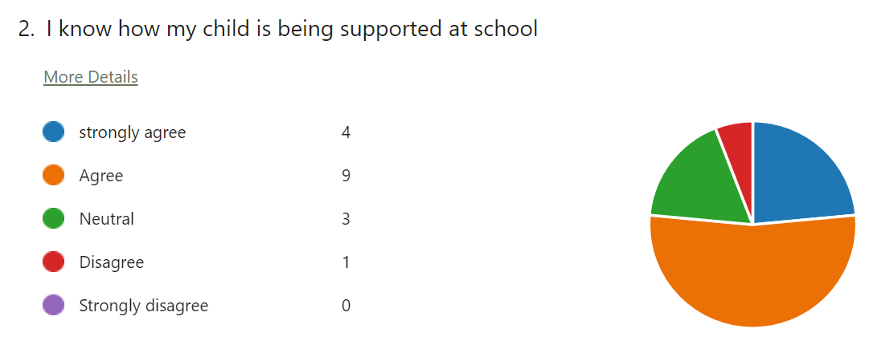  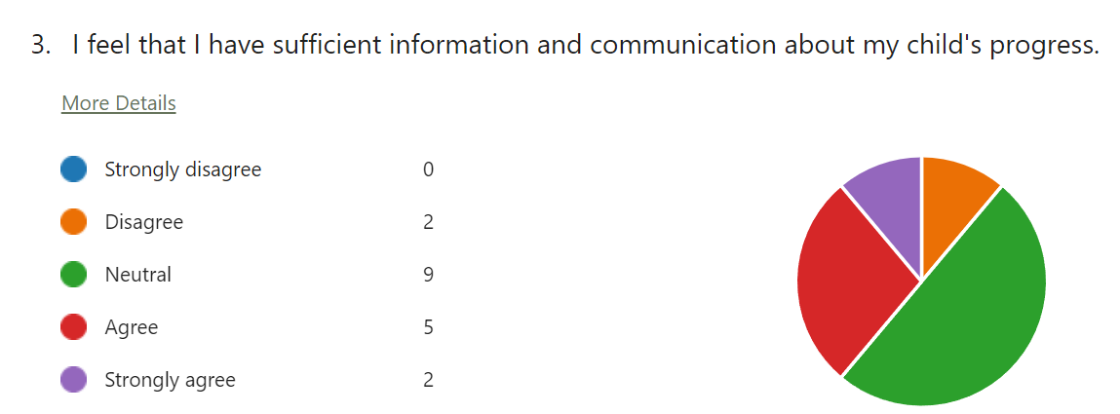  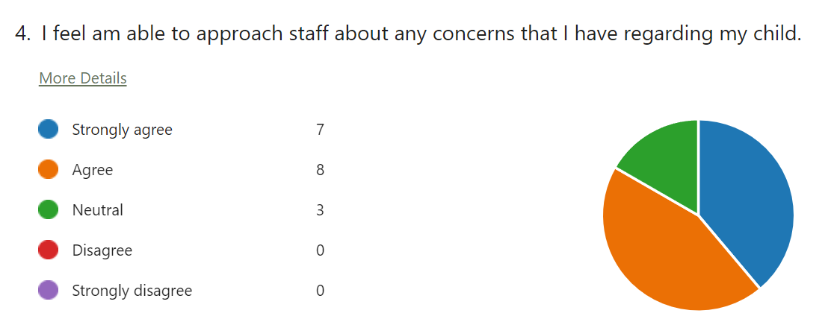  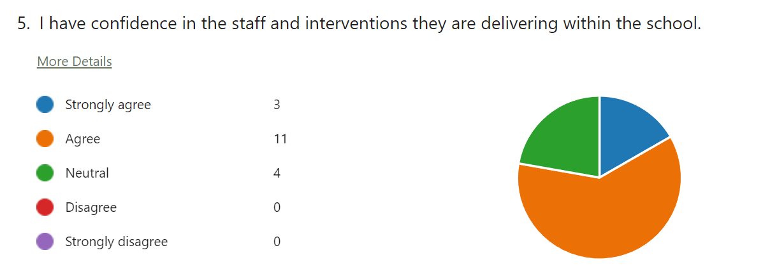  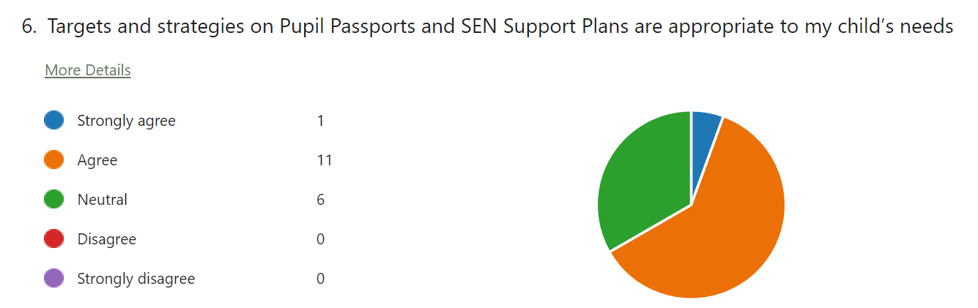  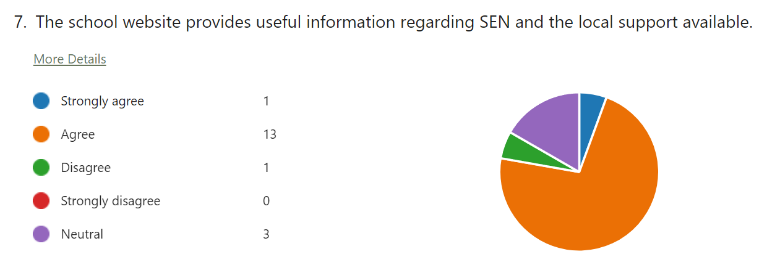  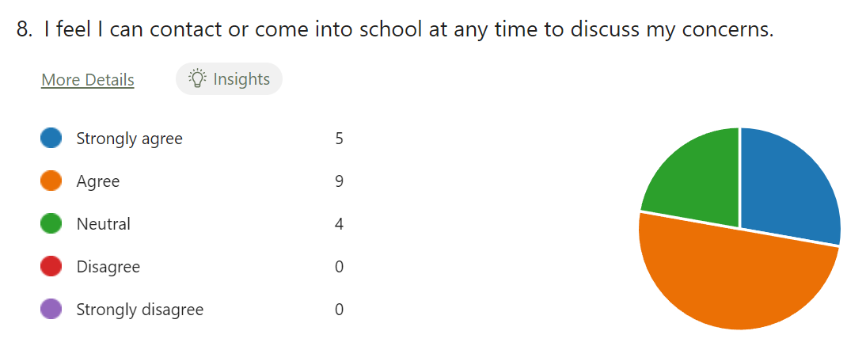  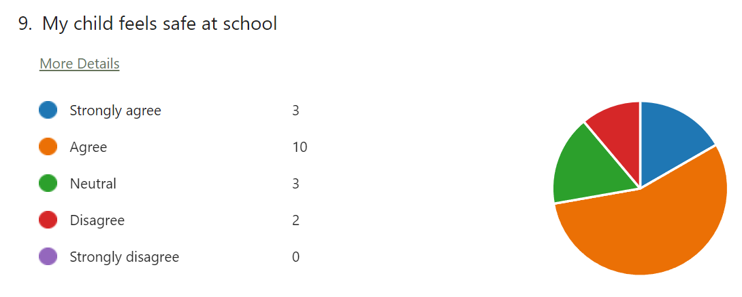  The survey outcomes were almost identicle to last year. I am proud of the work that the SENCO Team are doing here at Rushden Primary Academy and how reflective and adptive we are to support the children in our care.  With our ever changing demographic of students we will continue to do everything in our power to remove barriers to learning and help our children progress.
Child Consultations | Pupil’s views are very important; they have a right to be involved in decisions about their education and they are made aware of the support that surrounds them in Academy.  Children are fully involved and their views feed directly into all policies, procedures and daily teaching of children with SEND.  Pupils are given regular opportunities to:  Children will again be giving their voice in this year’s SEND questionnaire. The questionnaire is normally given out during the Autumn term so I can ensure any changes are implemented early in the year.
   |  | 
  Self-assess how they are doing | Attend meetings and help decide the support needed. | Feedback and Review progress/interventions.
  How we evaluate provision | Review progress in SLT meetings and discussing next steps.  Discuss and share ideas in staff meetings to ensure up to date research and policy is in place.  Reviewing children’ individual progress towards their goals at regular intervals, as a minimum every term.  Establishing children’s baseline before receiving interventions and reviewing the impact of interventions at regular intervals.  Asking our children if they feel the adjustment or intervention is helpful and makes a difference.  Monitoring by the SENDCO.  Regularly using a tracking tool to update targets and measure progress.  Holding termly reviews for children who are on Education Health and Care Plans, SEND Support Provision Plans and those requiring specialist support.  Holding annual reviews for children with Education Health Care Plans.
  Staff Training | At RPA, we believe in professional development and aim to ensure all our staff have the understanding they need to enable them to support your child.  When a new member of staff joins the Academy, we ensure they understand the systems within Academy and they are given information about the children they are working with.  The senior leadership team within Academy are constantly evaluating need and upskilling staff to support our learners.  If a child needs specialist support from an outside agency, such as the Speech and Language Service (SALT), Educational Psychologist (EP), Occupational Therapist (OT) or Academy nurse, we will always discuss concerns with parents first.
  Transition Support | EYFS Transition Success: A Year of Growth and Connection  This year, we proudly revamped our transition programme for children joining our EYFS provision and I’m delighted to share that it’s been a resounding success. Last year, we welcomed forty-seven children; this year, we reached full capacity with a waiting list, reflecting the strength of our approach and the trust placed in us by families.  Our enhanced transition included Stay and Play sessions, personalised parent meetings, and consistent nursery visits led by Mrs Nelson. These efforts have helped build strong, positive relationships between school, families, and early years settings. As a result, we’ve been able to have open, meaningful conversations that ensure every child receives the support they need from their very first day.  We’re incredibly proud of the collaborative spirit that has shaped this journey and even more excited to see how it continues to benefit our youngest learners.  Supporting Seamless Transitions Across Year Groups  At our school, we place great importance on ensuring that children experience smooth and positive transitions, starting with their move into Reception and continuing through each successive year group. This process is supported through a combination of parent meetings, information shared on Class Dojo, and taster sessions in the new classrooms.  As children prepare to move up a year, we ensure they spend meaningful time with their new teachers and teaching assistants, and have multiple opportunities to explore their new learning environment. These experiences help build familiarity and confidence ahead of the new academic year.  We recognise that some children may benefit from additional transition visits to help ease anxiety and support their emotional wellbeing. These extra sessions are carefully planned to ensure every child feels secure and ready to thrive.  To support continuity of care and learning, class teachers and teaching assistants meet during the summer term to share key information, including Individual Learning Plans and specific strategies that have supported each child. This collaborative approach ensures that every child’s needs are understood and met from day one.  Secondary Transition  We liaise very closely with all local High Schools to ensure that the transition from primary Academy to the secondary Academy is as smooth as possible. We organise additional days for children to attend their new setting if appropriate.  Mid-Year new starters  When we are aware that pupils joining us from other settings have identified special educational needs, we arrange a meeting with the family to enable us to gain a greater understanding on the support we need to put in place.
  Outside Agencies | We work with the following agencies to provide support for children with SEND:  Greenwood Academy Trust SEND Advisors,  Specialist Send Support service,  Rowan Gate Outreach,  Maplefields SEMH Outreach,  School Nurses,  Speech and Language Team,  Educational Psychology,  Mental Health Support Team.  Service Six  CAMHs  We always ask parent permission before we arrange for any outside agencies to come in and work with your child. Once the feedback has been received, this is shared with parents and Learning Plan’s updated.
  Clubs and Trips | All our extra-curricular activities and Academy visits are available to all our children in years 1-6, including our before-and after-Academy clubs.  All children are encouraged to go on our trips such as residentials and overnight stays.  All children are encouraged to take part in sports day, competitions, assemblies and performances, workshops, etc.  All children are encouraged to apply for roles of responsibility e.g. Academy council, House Captains, Digital Leaders, Junior Librarians etc.  No child is ever excluded from taking part in these activities because of their SEN or disability.
  Complaints Procedure | Your first point of contact is your child’s class teacher and/or phase leader.  If you are not satisfied that your concern has been addressed, then you may make an appointment to speak to the Deputy Principal, Mrs Larbey. If she cannot solve your issue, then an appointment can be made to speak to the Lindsay Edwards the Principal.
  North Northants Local Offer | The North Northants Local Authority Local Offer can be found at  https://localoffer.northnorthants.gov.uk/home
  Northants Children’s Trust | https://nctrust.co.uk/
  SEND Information Advice Support Service | https://www.sendiassnorthnorthants.co.uk/
  Parent  Feedback | “We were nervous about moving our child from a school they have spent many years in but it was a good decision! Our children have had more support at RPA than at their previous school”.  “The teachers go above and beyond to help – I never feel judged by them”.
  Final Thought | RPA remains fully committed to supporting all children’s individual needs and celebrating their progress.  As always, we value partnership between school and parents and welcome any feedback or questions you may have. Together, we can ensure your child receives the consistent, tailored support they deserve.  Thank you for your continued trust and collaboration.

