The Story of Carnegie Libraries

A Carnegie library is a library that was built with the help of money from Andrew Carnegie. Over 2,500 Carnegie libraries were built across the world. Between 1883 and 1919, Carnegie would give money to cities and towns to build a library. The cities or towns would have to give a place to build the library, and promise to give 10% of the cost of the library's construction each year for the library's costs. Many Carnegie library buildings still stand. Some are used for other purposes now. Most are made of brick. They often have a staircase leading up to the front door.

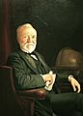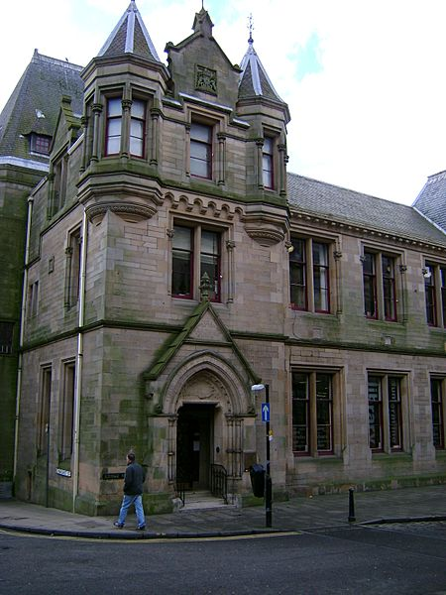

Libraries are an important part of Britain’s educational and social history and they are among our finest public buildings. They’ve existed in one form or another in the UK since at least the 16th century, but these early libraries were not always free for everyone to access and use.
Andrew Carnegie was born in Dunfermline in 1835. He lived with his family in a weaver’s cottage, now home to the Andrew Carnegie Birthplace Museum. In 1848 at the age of 12, Andrew and his family emigrated from Scotland to the United States of America.
By the end of the 1890s, the Carnegie Steel Company was making almost half of all the steel produced in America. After a series of mergers, the company became US Steel, the world’s first billion-dollar company.

Education and improvement
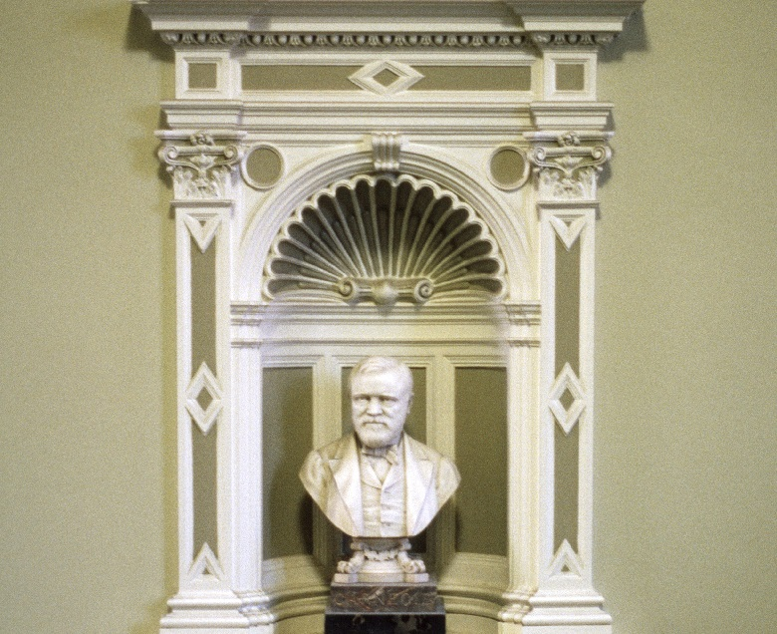
A bust of Andrew Carnegie (courtesy of the Public Monuments and Sculpture Association)
Now a very wealthy man, Andrew Carnegie still believed in the importance of education and self-improvement through life-long learning. He felt that the access he’d had to libraries as a young man was crucial to his success. At the height of his wealth he stated:
No millionaire will go wrong… who chooses to establish a free library in any community that is willing to maintain and develop it”
Carnegie set out to do just that, embarking on an ambitious project to provide funding for free public libraries throughout Britain and the USA.
The first of over 2500 Carnegie-funded libraries opened in his hometown in August 1883. The library was funded by an £8,000 grant provided by Carnegie and the rest was raised by taxation through the Public Libraries (Scotland) Act.
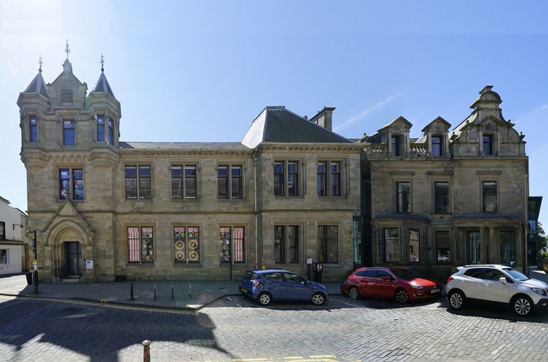
The Dunfermline Carnegie Library (© Oriel Prizeman Cardiff University AHRC “Shelf Life” project)

The Formula
Carnegie made adoption of the Public Libraries Act a requirement to access his donations. Known as the ‘Carnegie Formula’, town councils were required to demonstrate there was a public need for a library, that they could provide a suitable site and that they could maintain, furnish and stock them.
By 1904, around 60 towns had adopted the Act and many of these had also accessed Carnegie’s grant scheme.
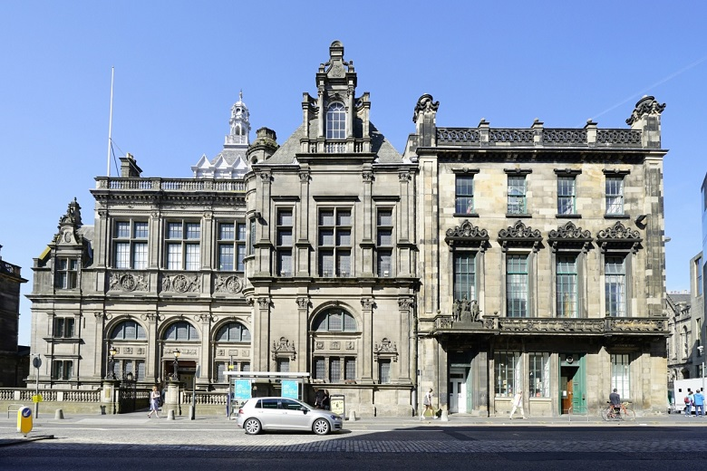
Edinburgh’s Central Library stands opposite the National Library of Scotland on George IV Bridge (© Oriel Prizeman Cardiff University AHRC “Shelf Life” project)
Many of these new public libraries were large and ornate buildings. The Central Library in Edinburgh, for example, opened in 1890. Part-funded by a Carnegie grant of £50,000, it was the city’s first public library.
Smaller branch libraries, village halls and reading rooms were also constructed using public library legislation and Carnegie’s grant scheme.
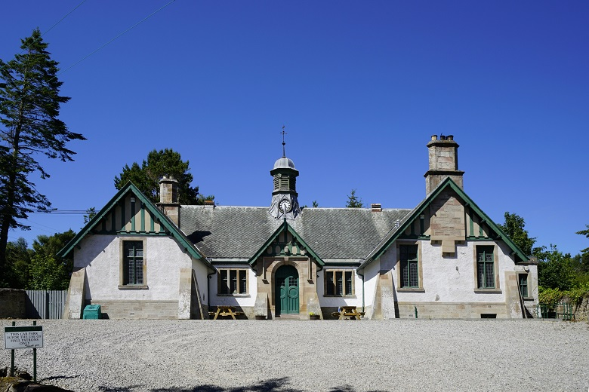
Clashmore Carnegie Hall, Dornoch, is an example of a rural facility built using Carnegie’s scheme (© Oriel Prizeman Cardiff University AHRC “Shelf Life” project)

The Carnegie legacy
Andrew Carnegie died in 1919. That same year, a new Public Libraries Act was passed. This Act transferred powers for libraries from town councils to county councils, meaning library services could be set-up across geographic areas. As a result, provision of libraries was less dependent on the money of wealthy patrons.
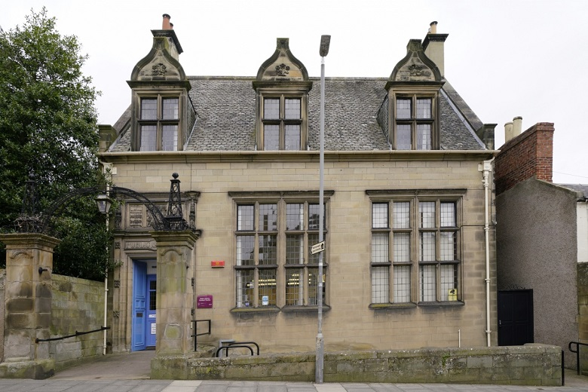
Kelso Library, constructed in 1906 (© Oriel Prizeman Cardiff University AHRC “Shelf Life”)
Because they’ve adapted and changed so much over time. Andrew Carnegie would not recognise the public library of today with its inclusive spaces, open-lending and digital services. Nonetheless, these buildings continue to be public spaces, open to everyone and free to use.
Our Library in Rushden is a Carnegie Library.
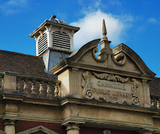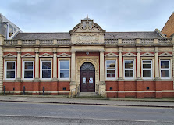

The Carnegie Medal
The Carnegie Medal is a British literary award that annually recognises one outstanding new English-language book for children or young adults. It is conferred upon the author by the Chartered Institute of Library and Information Professionals (CILIP).^{[1]} CILIP calls it "the UK's oldest and most prestigious book award for children's writing".^{[2]}
The Medal is named after the Scottish-born American philanthropist Andrew Carnegie (1835–1919), who founded more than 2,800 libraries in the English-speaking world, including at least one in more than half of British library authorities.^{[1]} It was established in 1936 by the British Library Association, to celebrate the centenary of Carnegie's birth^{[1][3]} and inaugurated in 1937 with the award to Arthur Ransome for Pigeon Post (1936) and the identification of two 'commended' books. The first Medal was dated 1936, but since 2007 the Medal has been dated by its year of presentation, which is now one or two years after publication.^{[4]}
In 1955, the Kate Greenaway Medal was established as a companion to the Carnegie Medal. The Kate Greenaway Medal recognises "distinguished illustration in a book for children".^{[5]} Both awards were established and administered by the Library Association, until it was succeeded by CILIP in 2002.^{[3]}
Nominated books must be written in English and first published in the UK during the preceding school year (September to August).^{[6]} Until 1969, the award was limited to books by British authors first published in England.^{[7]} The first non-British medalist was Australian author Ivan Southall for Josh (1972). The original rules also prohibited winning authors from future consideration.^{[7]} The first author to win a second Carnegie Medal was Peter Dickinson in 1981, who won consecutively for Tulku and City of Gold. There were eight repeat winners to 2018.
The winner is awarded a gold medal and £500 worth of books donated to the winner's chosen library. In addition, since 2016 the winner has received a £5,000 cash prize from the Colin Mears bequest.^{[1][8]}

