Intent – Rushden Primary Academy
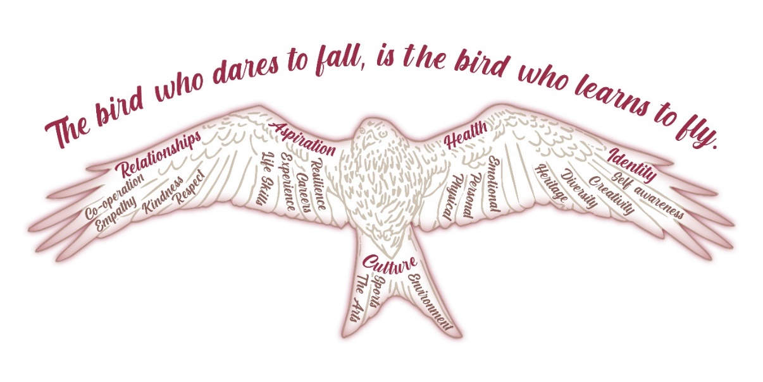
At Rushden Primary Academy our ethos of Respect, Pride, Achieve and our values-rich curriculum is at the centre of all that we do. Children are inspired in a happy, safe and inclusive environment where they can achieve their full potential, in order to succeed in our ever-changing world. We want to develop each child to become a caring, confident, and curious young person who has a passion for learning and achieving.
A focus on culture, with an emphasis on sports and The Arts provides a wider knowledge of the world and supports our children in finding their place in society and how they relate to it. We teach local and global environmental awareness by encouraging children to interact with the environment. This approach promotes a better understanding of their role to conserve the Earth’s finite resources through a more sustainable lifestyle.
The physical and mental health of our pupils is paramount; they are taught to be self-aware as well as being conscious of the needs of others. Children are taught emotional literacy which provides the ability to recognise, understand and self-regulate their emotions. These are important social skills so our children can be effective citizens of the future.
Our children have strong aspirations: our curriculum develops resilience and a growth mindset approach, where we learn from mistakes. We provide life-skills, experiences and careers information that encourage our children to break the glass ceiling by inspiring and motivating them.
Children at RPA have the opportunity to develop a strong sense of identity. They are provided with all of the tools to be self-aware and are taught the value of diversity and heritage. They are encouraged to be creative and true to themselves.
We value relationships: opportunities to develop empathy; the importance of co-operation and collaboration; learning to debate and compromise; and treat each other with kindness are the foundations of daily practice in school.

